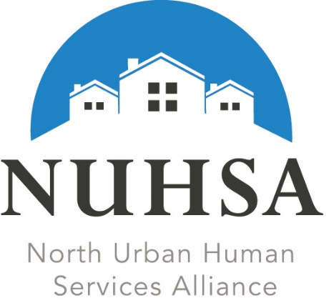

2019 NUHSA Human Services Awards

Request for Nominations

The North Urban Human Services Alliance (NUHSA) is seeking nominations for its 2019 Human Services Awards in two categories: Human Services Champion of the Year and Outstanding Human Services Program.

Do you know of an individual, organization or business in North King County (Shoreline, Lake Forest Park, Bothell, Kenmore and Woodinville) that has made a significant contribution to the health and welfare of our community? Have they in some way supported or advocated for strong and accessible health and human services and strengthened our community through their initiative and leadership?

If so, please give the recognition these individuals and organizations deserve!

Nominations are due Friday, November 1st, 2019.

Nominees and winners will be honored at NUHSA's 2019 Human Services Awards celebration on Tuesday, December 3rd, 2019 at 5:30 p.m. in the City of Shoreline Council Chambers. For more information or to RSVP for this community event, email staff@nuhsa.org.
NUHSA’s Annual Human Services Awards ceremony has been celebrating the accomplishments of local individuals and organizations since 2008. NUHSA is an alliance of non-profit agencies, faith communities, city and county leadership, school districts and members of the community who advocate for a strong and accessible health and human services system in North King County, encompassing Shoreline, Lake Forest Park, Kenmore, Bothell and Woodinville. Through partnership and collaboration, NUHSA supports providers, funders and the community to enhance existing resources and build our capacity to effectively respond to community needs.

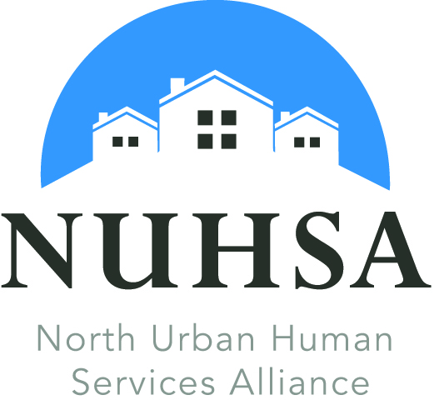

2019 NUHSA Human Services Awards Nomination

AWARD CATEGORY  (Please select one) | Human Services Champion of the Year  Outstanding Human Services Program

Nomination Deadline: Friday, Nov. 1st, 2019
By Email: staff@nuhsa.org
By Mail: NUHSA Award Selection Committee
P.O. Box 60215 Shoreline, WA 98160

Nominee Name: _____________________________________________________________________
Agency: _________________________________________Email: _____________________________
Address: ___________________________________________________________________________
City: ________________________ Zip: ________________ Phone: (______) ____________________

Nominated By: ________________________________________ Email: ________________________

Address: ___________________________________________________________________________

City: ____________________________ Zip: ________________ Phone: (______) ________________

Signature: __________________________________________________________________________
Above signature authorizes sharing and publishing of this nomination

Nominations will be reviewed by a committee of the NUHSA Board of Directors and will be based on answers submitted to the following questions:
- What is/are the name(s) of the group(s) or organization(s) served?
- Which community was the service provided in (must be within North King County including Bothell, Kenmore, Lake Forest Park, Shoreline and Woodinville)?
- Please describe the work that inspired you to nominate this individual or organization for the award.
- How has the work of the nominee improved the community, enhanced the lives of its residents for which/whom the work was performed or inspired others?
- What is inspiring, courageous, unusual or innovative about the nominee's achievement?

Winners & Nominees will be acknowledged at the
NUHSA Annual Meeting
Tuesday, December 3, 2019
5:30 – 7:00 p.m.
Shoreline City Hall Council Chambers
17500 Midvale Avenue North
Shoreline, WA 98133

Questions: staff@nuhsa.org

