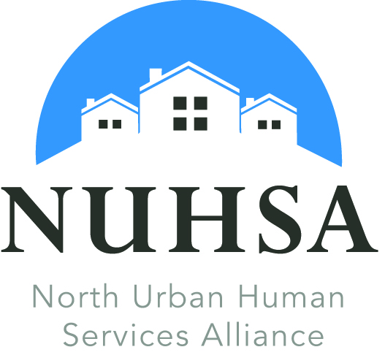

2015 Human Service Awards Nomination
AWARD CATEGORY  (Please select one) | Volunteer of the Year  Outstanding Volunteer Program

Nomination Deadline: Monday, November 2, 2015
By Email: staff@nuhsa.org
By Mail: NUHSA Award Selection Committee,
P.O. Box 60215 Shoreline, WA 98160
Nominee Name: ________________________________________________________________
Agency: _______________________________Email:__________________________________
Address: ______________________________________________________________________
City: ________________________ Zip: __________________ Phone: (___) ________________
Nominated By: __________________________________ Email: ________________________
Address: ______________________________________________________________________
City: ____________________________ Zip: ________________ Phone: (___) ______________
Signature: _____________________________________________________________________
Above signature authorizes sharing and publishing of this nomination

Instructions:
Nominations will be reviewed by a committee of the Board and will be based on answers submitted to the following questions:
1. What is/are the name(s) of the group(s) or organization(s) served?

2. Which community was the service was provided (must be within North King County
including Bothell, Kenmore, Lake Forest Park, Shoreline and/or Woodinville)?

3. Please describe the volunteer work that inspired you to nominate this individual or
organization for the award.

4. How has the nominee's work supported NUHSA's vision and mission?

5. How has the work of the nominee improved the community, enhanced the lives of its residents for which/whom the work was performed or impacted volunteers or inspired others to volunteer?

6. What is inspiring, courageous, unusual or innovative about the nominee's achievement?

Winners and Nominees will be acknowledged at the
NUHSA Annual Meeting
Tuesday, December 8, 2015
5:30p.m. – 7:00p.m.
Shoreline City Hall Council Chambers
17500 Midvale Avenue North
Shoreline, WA
Questions: staff@nuhsa.org or NUHSA Staff at 206‐675‐2900.

